NAME : **Sujan Biswas**

BATCH : BCSE 2nd Year (Lateral)

ROLL NO: 302010501003

Microprocessor lab in ASSIGNMENT #1:

1.Load the contents of the memory locations 2200H into registers .Add these register and store the results in memory location 2202 H & 2203 H.

|  |  |  |  |  |  |
| --- | --- | --- | --- | --- | --- |
| SL NO | ADDRESS | OPCODE IN HEX | LABEL | INSTRUCTIONS | COMMENTS |
| 1 | 2200 | 3A,00,22 |  | LDA 2200 | Load accumulator direct address of 2200H. |
| 2 | 2203 | 47 |  | MOV B,A | Move accumulator to b register. |
| 3 | 2204 | 3A,01,22 |  | LDA 2201 | Load accumulator direct into memory location 2201H. |
| 4 | 2207 | 0E,00 |  | MVI C,00 | Move immediate value 2200 memory address into c register. |
| 5 | 2209 | 80 |  | ADD B | Add register b with accumulator |
| 6 | 220A | D2,0E,22 |  | JNC L1 | When carry flag is 0,its jump. |
| 7 | 220D | 0C |  | INR C | Increase c ,when carry is 1. |
| 8 | 220E | 32,02,22 | L1 | STA 2202 | Store the accumulator memory address 2202H. |
| 9 | 2211 | 79 |  | MOV A,C | Move c register to accumulator |
| 10 | 2212 | 32,03,22 |  | STA 2203 | Store accumulator memory address 2203H |
| 11 | 2215 | 76 |  | HLT | Termintate the program |

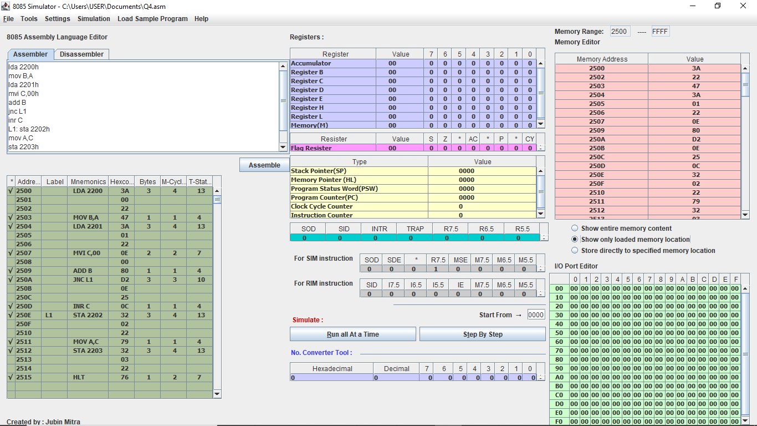

2.Find the sum of N numbers stored in consecutive locations staring from 2500 H.The value of N is stored in 2200 H. Store the results in location 2300 H and 2301 H.

|  |  |  |  |  |  |
| --- | --- | --- | --- | --- | --- |
| SL NO | ADDRESS | OPCODE IN HEX | LABEL | INSTRUCTION | COMMENTS |
| 1 | 2500 | 3A,00,22 |  | LDA 2200 | Load accumulator direct memory location 2200H . |
| 2 | 2503 | 57 |  | MOV D ,A | Move accumulator to d register. |
| 3 | 2504 | 21,00,25 |  | LXI H,2500 | Load first instruction address 2500H. |
| 4 | 2507 | 7E |  | MOV A,M | Move memory address to accumulator. |
| 5 | 2508 | 06,00 |  | MVI B,00 | Move immediate to b register. |
| 6 | 250A | 0E,00 |  | MVI C,00 | Move immediate to c register. |
| 7 | 250C | 80 | L1 | ADD B | Add b register with accumulator. |
| 8 | 250D | D2,11,25 |  | JNC L2 | Jump when carry is O. |
| 9 | 2510 | 0C |  | INRC | Increment c when carry is 1. |
| 10 | 2511 | 47 | L2 | MOV B,A | Move accumulator to b register. |
| 11 | 2512 | 23 |  | INX H | Increase HL pair. |
| 12 | 2513 | 7E |  | MOV A,M | Move memory location to accumulator. |
| 13 | 2514 | 15 |  | DCR D | Decrement d register. |
| 14 | 2515 | C2,0C,25 |  | JNZ L1 | Jump when z flag is 0. |
| 15 | 2518 | 78 |  | MOV A,B | Move b register to accumulator |
| 16 | 2519 | 32,00,23 |  | STA 2300 | Store accumulator memory location 2300 |
| 17 | 251C | 79 |  | MOV A,C | Move c register to accumulator |
| 18 | 251D | 32,01,23 |  | STA 2301 | Store accumulator memory location 2301 |
| 19 | 2520 | 76 |  | HLT | Terminate the program. |

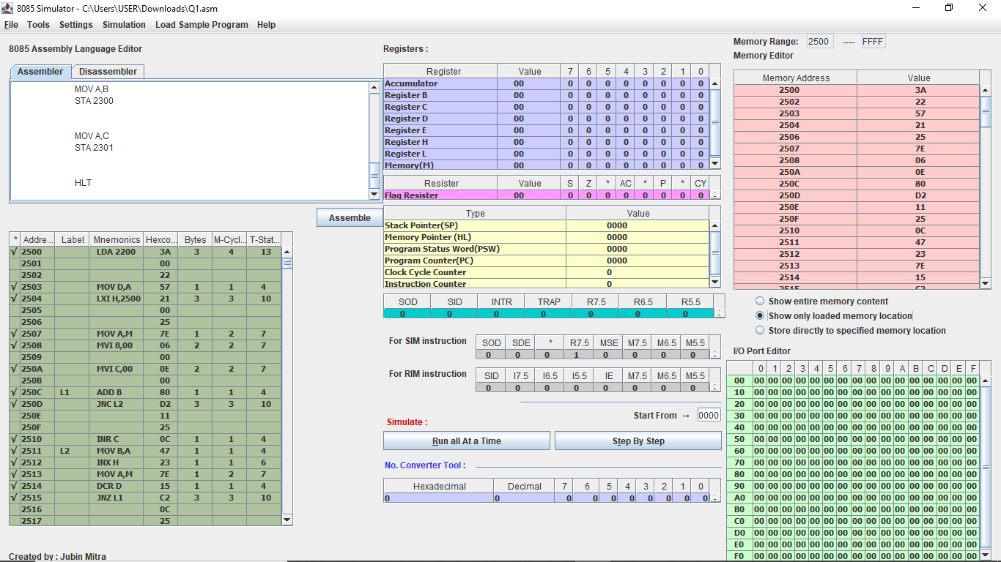

3.Find the sum of the least significant 4 bits and most significant 4 bits of a byte stored in memory location 2500H. store the result in 2550 H.

|  |  |  |  |  |  |
| --- | --- | --- | --- | --- | --- |
| SL NO | ADDRESS | OPCODE IN HEX | LABEL | INSTRUCTION | COMMENTS |
| 1 | 2500 | 21,00,25 |  | LXI H,2500H | Contents of memory location 2500H into HL register pair. |
| 2 | 2503 | 7E |  | MOV A,M | Move memory address to accumulator A=M[HL] |
| 3 | 2504 | E6,0F |  | ANI 0FH | A=A&(0000 1111) |
| 4 | 2506 | 57 |  | MOV D,A | D=A |
| 5 | 2507 | 7E |  | MOV A,M | A=M[HL] |
| 6 | 2508 | 0F |  | RRC | Rotate bits of accumulator right without carry bit |
| 7 | 2509 | 0F |  | RRC | Rotate bits of accumulator right without carry bit |
| 8 | 250A | 0F |  | RRC | Rotate bits of accumulator right without carry bit |
| 9 | 250B | 0F |  | RRC | Rotate bits of accumulator right without carry bit |
| 10 | 250C | E6,0F |  | ANI 0FH | A=A&(0000 1111) |
| 11 | 250E | 82 |  | ADD D | A=A+D |
| 12 | 250F | 32,50,25 |  | STA 2550H | Load the contents of the accumulator in the address location 2550H ,M[2550] |
| 13 | 2512 | 76 |  | HLT | Stop the program. |

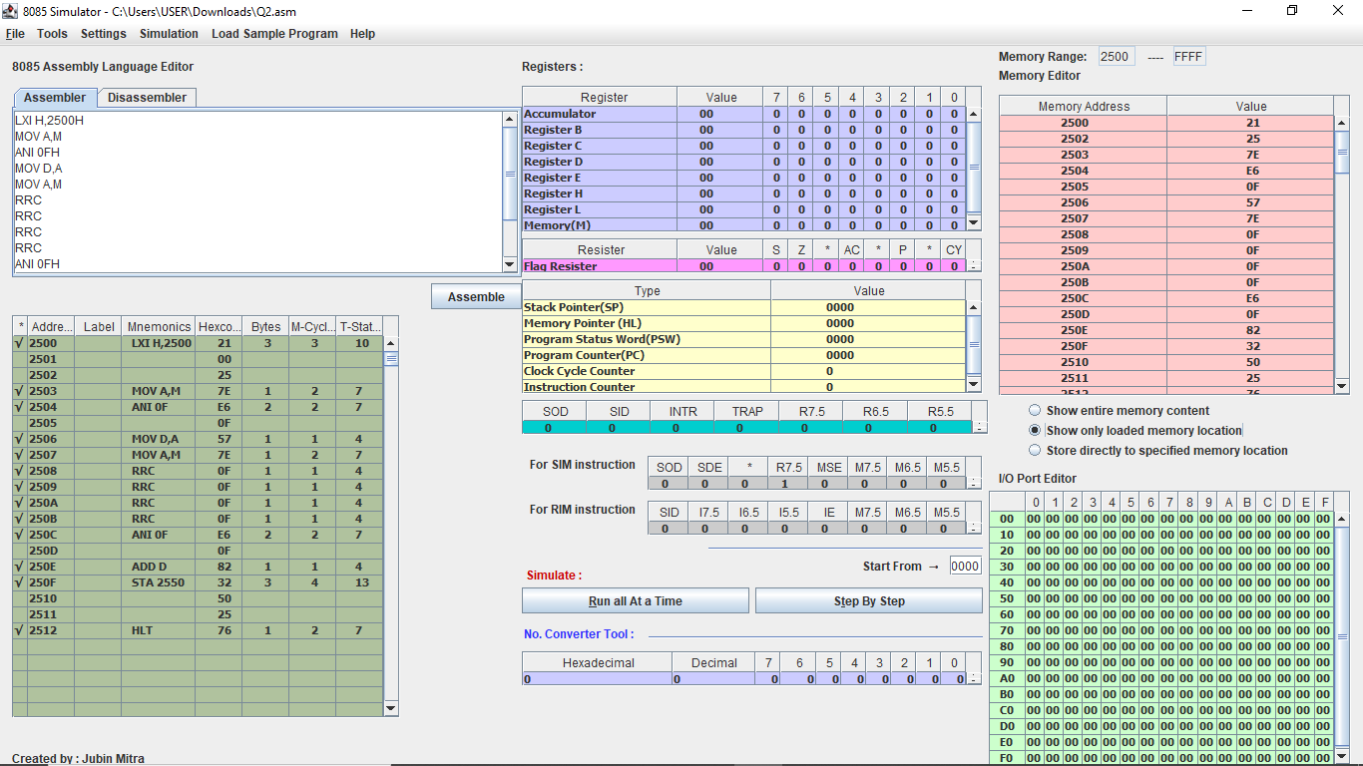

4.Write a program to count the 1’s and 0’s of a byte stored in 2500 H.Store in 2610 H,and 2511 H,respectively.

|  |  |  |  |  |  |
| --- | --- | --- | --- | --- | --- |
| SL NO | ADDRESS | OPCODE IN HEX | LABEL | INSTRUCTIONS | COMMENTS |
| 1 | 2500 | 21,00,25 |  | LXI H,2500H | Contents of memory location 2500H into HL register pair. |
| 2 | 2503 | 7E |  | MOV A,M | A=M |
| 3 | 2504 | 06,08 |  | MVI B,00H | B=08H |
| 4 | 2506 | 16,00 |  | MVI D,00H | D=00H |
| 5 | 2508 | 07 | LOOP | RLC | Rotate accumulator left without carry. |
| 6 | 2509 | D2,0D,00 |  | JNC SKIP | If no carry is generated the jump to label skip |
| 7 | 250C | 14 |  | INR D | D=D+1[To get the one count] |
| 8 | 250D | 05 | SKIP | DCR B | B=B-1 |
| 9 | 250E | C2,08,00 |  | JNZ LOOP | If contents of B is not zero then jump to the label LOOP,we need to continue this 8 times to get the count of all set bits |
| 10 | 2511 | 7A |  | MOV A,D | A=D |
| 11 | 2512 | 32,10,26 |  | STA 2610H | Load the contents of the accumulator in the address location 2610H,M[2610]=A(store the number of ones) |
| 12 | 2515 | 47 |  | MOV B,A | B=A |
| 13 | 2516 | 3E,08 |  | MVI A,08H | A=08H |
| 14 | 2518 | 90 |  | SUB B | A=A-B(To get a zero count) |
| 15 | 2519 | 32,11,25 |  | STA 2511H | Load the contents of the accumulator in the address location 2511H,M[2511]=A(store the number of ones) |
| 16 | 251C | 76 |  | HLT | Stop the program. |

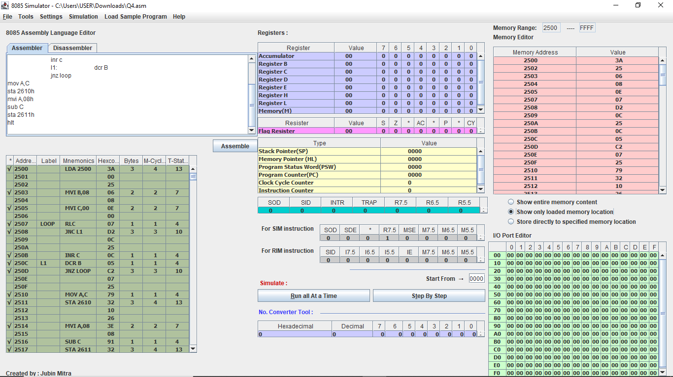

5.Write a program to sum two 16 bits binary numbers.

|  |  |  |  |  |  |
| --- | --- | --- | --- | --- | --- |
| SL NO | ADDRESS | OPCODE IN HEX | LABEL | INSTRUCTIONS | COMMENTS |
| 1 | 2500 | 21,00,25 |  | LXI H, 2500H | Contents of memory location 2500H into HL register pair |
| 2 | 2503 | 7E |  | MOV A,M | A=M[HL  ] |
| 3 | 2504 | 21,02,25 |  | LXI H,2502H | Contents of memory location 2502H into HL register pair |
| 4 | 2507 | 46 |  | MOV B,M | B=M[HL] |
| 5 | 2508 | 80 |  | ADD B | A=A+B |
| 6 | 2509 | 32,10,25 |  | STA 2510 | Load the contents of the accumulator in the address location 2510H,M[2510]=A |
| 7 | 250C | 3E,00 |  | MVI A,00H | A=00H |
| 8 | 250E | 8F |  | ADC A | Add the carry generated |
| 9 | 250F | 32,11,25 |  | STA 2511H | Load the contents of the accumulator in the address location 2511H,M[2511]=A |
| 10 | 2512 | 21,01,25 |  | LXI H,2501 | Contents of memory location 2501H into HL register pair |
| 11 | 2515 | 56 |  | MOV D,M | D=M[HL] |
| 12 | 2516 | 82 |  | ADD D | A=A+D |
| 13 | 2517 | 21,03,25 |  | LXI H,2503H | Contents of memory location 2503H into HL register pair |
| 14 | 251A | 56 |  | MOV D,M | D=M[HL] |
| 15 | 251B | 82 |  | ADD D | A=A+D |
| 16 | 251C | 32,11,25 |  | STA 2511H | Load the contents of the accumulator in the address location 2511H,M[2511]=A |
| 17 | 251F | 3E,00 |  | MVI A,00H | A=00H |
| 18 | 2521 | 8F |  | ADC A | Add the carry to the accumulator |
| 19 | 2522 | 32,12,25 |  | STA 2512H | Load the contents of the accumulator in the address location 2512H,M[2512]=A |
| 20 | 2525 | 76 |  | HLT | Stop the program |

